國立臺北科技大學系所自聘
「全英語授課課程勞僱型兼任助理」申請表
Application Form for EMI TA Recruitment
年Year/ 月Month/ 日Day
用人單位  Employing Unit |  | 學院 系所  Department of College of
基本資料Personal Information | 姓名  Name |  |  | 身分證字號  ARC No. |  | 手機號碼  Cellphone No.
基本資料Personal Information | 學號  Student ID |  |  | 系所/年級  Dept./ Grade | □大學部UG □研究所Grad □博士班PhD  □一年級Y1 □二年級Y2 □三年級Y3  □四年級Y4 □五年級Y5
基本資料Personal Information | 通訊地址  Address |  |  |  | 電子信箱  Email
基本資料Personal Information | *工作許可證  有效日期  Work permit Date of expiry | *僅外籍學生須提供  Only required for foreign students |  |  | 出生年月日  Date of birth | Y__ __ __ __ M__ __ D__ __
基本資料Personal Information | *工作許可證  有效日期  Work permit Date of expiry |  |  |  | 國籍  Nationality
課程資訊 Course Info. | 課程名稱  Course Name |  |  | 課號  Course No. |  | 開課班級  Class
課程資訊 Course Info. | 學分數  Credits |  |  | 授課教師  Instructor |  | 授課時間  Schedule
課程資訊 Course Info. | 英語程度/ 檢定成績  English proficiency/ CEFR Score
統一規章Unified Regulations | - 自113-2學期起，未達CEFR B1者不予聘任。  Students who do not meet the CEFR B1 level will not be eligible starting from the 2025 Spring Semester.  - 未達CEFR B2者，須參加當學期英文期中會考/培力英檢，考試成績通過與否不影響TA資格。*任意一項考試無故未到考者，將不予核發該學期最後一個月之工讀金；有故請提出相關證明。  Students who have not yet reached CEFR B2 level must take the English midterm proficiency test or BESTEP during the semester. The test results will not affect TA eligibility.  *Please note that absence from either exam without a valid justification will result in the forfeiture of the last month’s TA wage from that semester. A valid documentation must be provided for excused absences.  - 每院英文能力達CEFR B2之EMI TA人數，需佔該院當學期聘任總EMI TA人數之60%(含)以上。  In each department, the number of EMI TAs who meet the CEFR B2 level must account for at least 60% of the total number of EMI TAs appointed during the semester.  - 因學生英文能力未達教育部規定CEFR B2，須由授課教師簽字保證該名學生的英文能力足以在課堂中提供幫助。學生除每月配合參與一場TA培訓工作坊外，另須參與由雙語中心安排之英文能力提升小組輔導(每月2小時)，檢核未完成者將不予申請當月EMI TA工讀金。  For students whose English proficiency does not meet the CEFR B2 requirement, the course instructor must sign a declaration confirming the student’s ability to effectively assist in the EMI classroom. In addition to attending a TA training workshop per month, such students must also participate in English proficiency enhancement group organized by Center for Bilingual Learning (2 hrs per month). Failure to fulfill these requirements will result in the suspension of the TA’s wage for that month.  - 外籍生未達CEFR B2，每月必須另行參加一次Fulbright工作坊/諮詢。  International students who have not yet reached CEFR B2 must additionally participate in a Fulbright workshop or consultation session per month.
工作內容 Work Contents | 須回傳雙語中心Required to submit to Center for Bilingual Learning：  - 協助側錄課堂師生互動，並提供給雙語中心。  Record instructors-students’ interaction and lecture clips.  - 提供特色教學文件給雙語中心。  Submit featured course materials to the Center for Bilingual Learning.  - 每週進行實體/線上1-3hr輔導諮詢，錄影留存後提供給雙語中心。  Provide weekly tutorial sessions (1-3 hrs/week) to students, record tutoring sessions and submit to the Center for Bilingual Learning.  - 每月須配合參與一場TA培訓工作坊，因故未能出席者請於當月完成參與一次TA Make-up session。  Attend a TA training workshop every month. If you are unable to attend, please complete a TA Make-up session within the same month.  *將於當學期最後一次提交工作日誌時進行個人參與次數總結算，未達成之次數將依規定扣除時薪，每缺少1次活動參與= 1時薪。  *The total number of personal participation instances will be calculated when submitting the work log for the last time of the semester. For each missed participation, an hourly wage deduction will be applied according to the regulations, with 1 missed instance equaling a deduction of 1 hour's wage.  - 其他雙語中心指定事務。  Others required by Center for Bilingual Learning.  由教師安排Required by instructors：(請由教師勾選Marked by instructors)  □ 向老師要教材上傳北科i-學園  Upload course materials to NTUT i-Study  □ 管理課程line群組  Manage LINE class group  □ 協助教師EMI課程備課  Assist instructors in preparing EMI courses  □ 協助教師EMI課程現場教學、實驗及實務操作  Assist instructors in on-site EMI teaching, including experiments and practical operations.  □ 作業批改、算成績  Assignment correction and grade calculation  □ 教具器材準備、架設與操作  Preparation, erection, and operation of teaching aids  □ 其他Others ____________________________________  - 本人已詳閱、瞭解並同意上述告知及聲明事項內容。  I have read and understood the contents of the above notice and declaration, and hereby agree to the terms.  授課教師簽章Instructor signature 學生簽名Student signature

學生證件資料黏貼表 Form for Copies of Personal Document
電話  Contact No. |  | □已繳畢註冊費 Tuition paid  □碩一生繳附最高學歷證明文件Diploma
Email | @gmail.com | □已繳畢註冊費 Tuition paid  □碩一生繳附最高學歷證明文件Diploma
身份別 | 是否為原住民： □是 □否 | 身心障礙人士： □否 □輕 □中 □重度
身份證 正面影本(黏貼處)  Please stick the copy of  front side of ID card here |  | 身份證 反面影本(黏貼處)  Please stick the copy of  back side of ID card here
健保卡 正面影本(黏貼處)  Please stick the copy of  front side of National Health Insurance card here |  | 健保卡反面影本(黏貼處)  Please stick the copy of  back side of National Health Insurance card here
學生證 正面影本 (黏貼處)  Please stick the copy of  front side of student ID card here |  | 學生證 反面影本 (黏貼處)  Please stick the copy of  back side of student ID card here
存摺 正面影本(黏貼處)
Please stick the copy of bankbook cover here
需提供文件Required documents *此頁不須列印This page does not need to be printed
□「全英語授課課程勞僱型兼任助理」申請表
Application Form for EMI TA Recruitment
□ 學生證件資料黏貼表
Form for Copies of Personal Document
- 英語能力證明 (Ex. GEPT, TOEIC, TOEFL, IELTS 成績單影本)
Proof of English proficiency (Ex. GEPT, TOEIC, TOEFL, IELTS copy of transcripts)
- 114-1學期在學證明(於第三教學大樓一樓聯合服務中心申請)
Certificate of Enrollment in Fall 2026 (Apply at the Joint Service Center on the 1st floor of the Third Teaching Building)
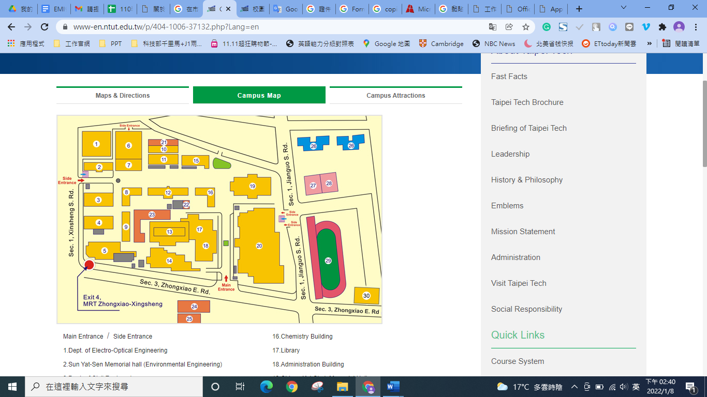
- 工作許可證明(僅外籍生須提供)
Work permit (Only required for foreign students)
※請參考國際處工作許可證申請辦法(https://oia.ntut.edu.tw/p/412-1032-9105.php?Lang=zh-tw)
※Reference: Apply for Work Permit (https://oia.ntut.edu.tw/p/412-1032-13812.php?Lang=en)

